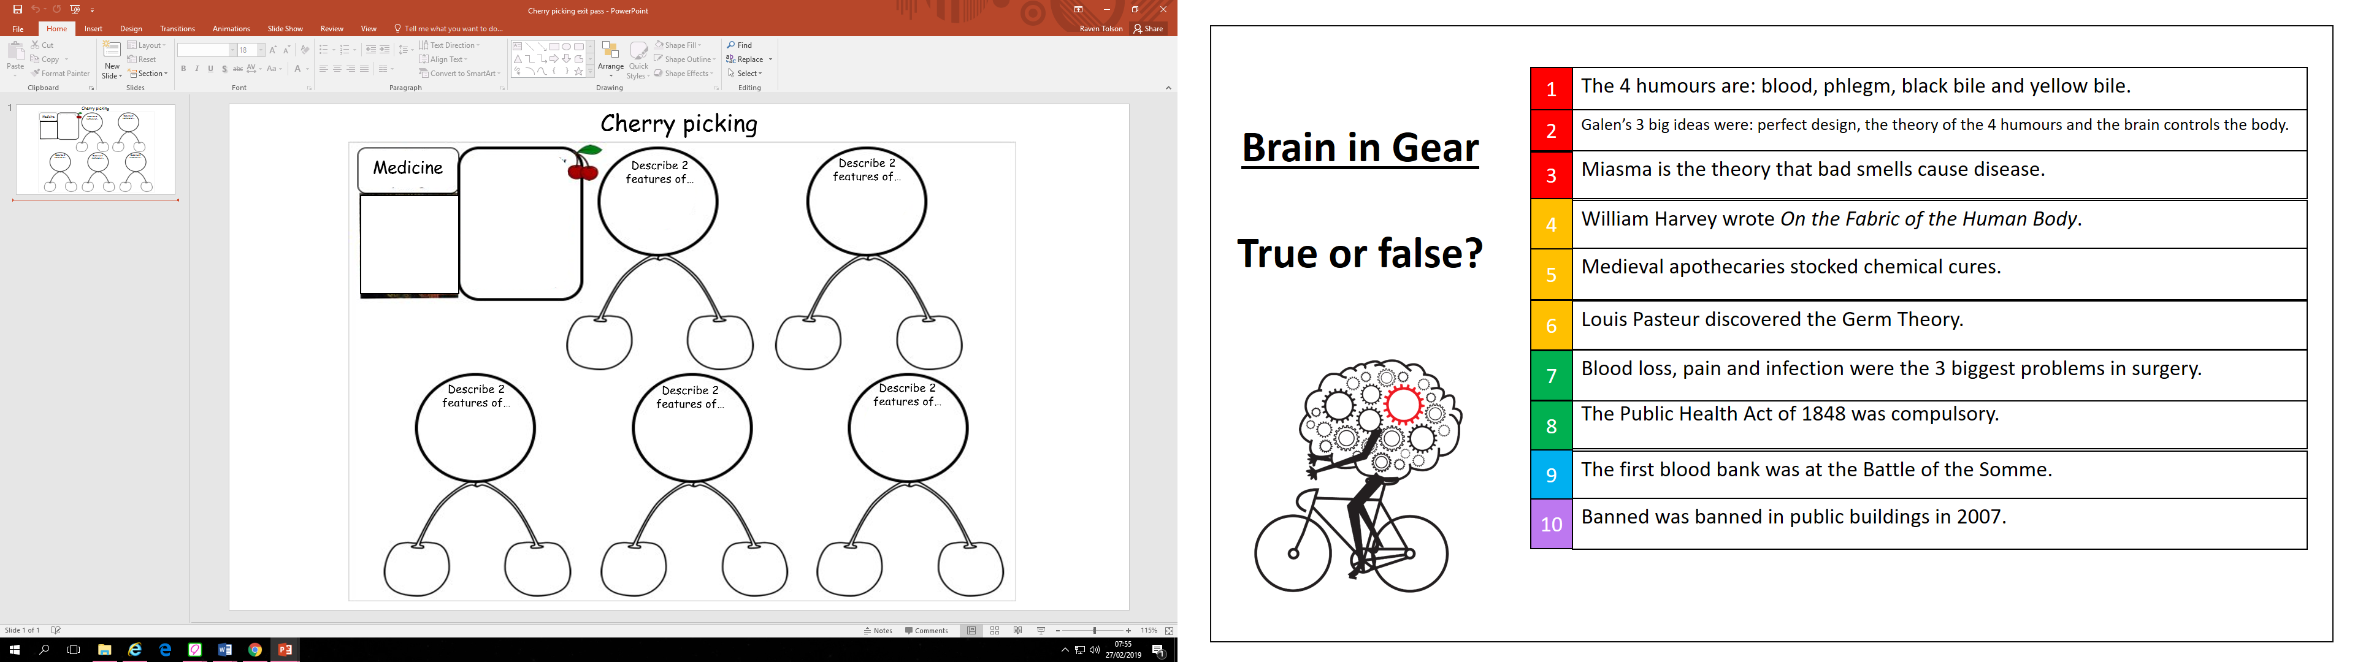

Feature 2 …………………………………………………………………………………………………………….

…………………………………………………………………………………………………………………………………

…………………………………………………………………………………………………………………………………

.....................................................................................................................................

Feature 1………………………………………………………………………………………………………………

…………………………………………………………………………………………………………………………………

…………………………………………………………………………………………………………………………………

.....................................................................................................................................

Feature 2 ……………………………………………………………………………………………………………..

…………………………………………………………………………………………………………………………………

…………………………………………………………………………………………………………………………………

.....................................................................................................................................

Feature 1……………………………………………………………………………………………………………….

…………………………………………………………………………………………………………………………………

…………………………………………………………………………………………………………………………………

.....................................................................................................................................

what people thought caused the Great Plague (1666).

what people thought caused the Black Death (1348).